DISTRICT PROFILE
- Name of District : Jaintia Hills District
- Geographical Position : Latitude :
Longitude:
Altitude:

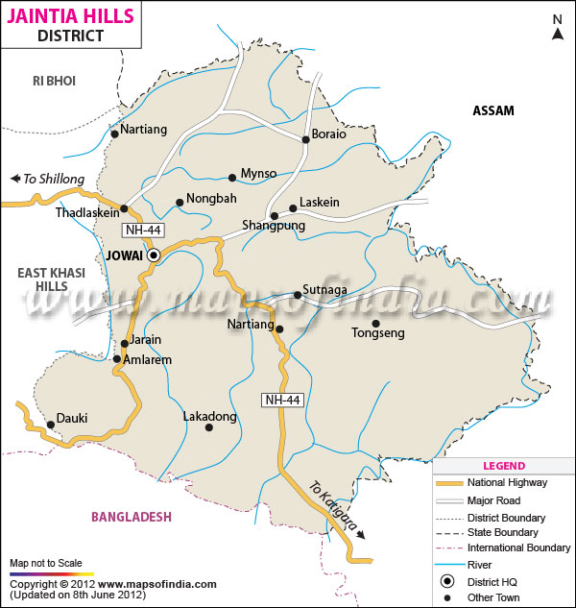

- Total Geographical area : 381900
- District Headquarters name : Jowai
- Demographic details :

Sl. No. | Particulars | Value
I | Population
 | Male | 196285
 | Female | 198839
 | Total Population | 395124
 | Rural | 366694
 | Urban | 28430
Ii | Population Density/ Sq. km | 103
Iii | Literates
 | Male (%) | 58.1%
 | Female (%) | 65%
 | Total (%) | 62%
Iv | Details on SC/ST Population
 | Male | ST- 185866 SC – 290
 | Female | ST – 190233 SC – 166
 | Total Population
 | Literacy rate (%) | -
 | Male | -
 | Female | -
 | Total | -
V | Labour profile
 | Total workers | 110617
 | Male workers | 67267
 | Female workers | 43350
 | Rural workers | -
 | Urban workers | -
 | Cultivators | 27273
 | Agricultural Labourers | 18600
 | Household industry | 1283
 | Other workers | 47069
 | Marginal workers | 43563
 | Non Workers | 240944
 | Average labour wages for farm operations (Rs. / manday of seven to nine hours) | Skilled Job | Unskilled job
 | Peak seasons
 | Male
 | Female
 | Lean seasons
 | Male
 | Female
Vi | Major languages spoken in the district
 | Details on Birth – Death rate ( per 1000 population)
 | Birth rate
 | Death rate
 | Infant mortality rate
 | Expectation of life in years
 | Male
 | Female

- Taluk details:
Sl. No. | Name of the Taluk/ Tehasil | Total area in ha | Taluk HQ
1
2

- Block details
Sl No. | Name of the Block | Total area in ha | No. of Panchayats | No. of Revenue villages | Total Population inclusive of SC/ST population |  |  | SC/ST population
 |  |  |  |  | Male | Female | Total | Male | Female | Total
1 | Thadlaskein | 896.60 |  |  | 55230 | 55279 | 109509
2 | Laskein | 390.40 |  |  | 45244 | 45158 | 90402
3 | Amlarem | 398 |  |  | 21903 | 21941 | 43844
4 | Khliehriat | 1280 |  |  | 42628 | 43204 | 85832
5 | Saipung | 846 |  |  | 18605 | 18502 | 37107
6 | Jowai | 8 |  |  | 13675 | 14755 | 28430
7
8
9
10
11

- Block wise Literacy rate (%): NA

Sl No. | Name of the Block | Other than SC/ST population |  |  | SC/ST population |  |  | Total population
 |  | Male | Female | Total | Male | Female | Total | Male | Female | Total
1
2

- Educational and other infrastructural facilities of latest available (2011)
Sl. No. | Particulars | Numbers / Values
1 | Educational facilities
 | Pre-primary (Nursery school)
 | Primary | 1713
 | Middle/ U.P | 578
 | High/Secondary Schools | 71
 | Higher –Secondary | 18
2 | Professional colleges | NA
 | Medical | NA
 | Engineering | NA
 | Agriculture | NA
 | Veterinary/ Fisheries | NA
 | Others (Please specify) Govt. Aided Colleges | NA
3 | Number of Arts and Science Colleges | 6
4 | Institutional Credit facility
 | Name of the lead bank
 | No. of branches of lead bank in the district
 | Other commercial banks
 | Primary land development bank
 | District Central Co- operative Credit society
 | Housing Co-Operative Societies
 | Employees Co-Operative Societies
 | Weavers Co-Operative Societies
 | Industrial Co-Operative Societies
 | Khadi and Village Industries Societies
 | Primary Co-Operative Societies
 | Co-Operative Sugar mills
 | Other Marketing Society ( Please specify)
5 | Agricultural Marketing and Processing
a) | No. of Regulated Markets
b) | No. of Co-Operative Marketing Society
c) | No. of Permanent Markets / Central Markets | 14
d) | No. of Weekly Markets / Shandies | 14
e) | No. of Dying yards
f) | No. of Storage Godowns
g) | No. of Cold Storage units for agricultural produce for floriculture
h) | No. of agro based / agri-based processing industries
i) | Small Scale
ii) | Medium Scale
iii) | Large Scale | -

- Agro- climatic features
- Rainfall pattern during 2012-13 or latest available year
Sl No. | Month | Rainfall in mm
 |  | Actual | Normal | % deviation
 | April’12
 | May’12
 | June’12
 | July’12
 | August’12
 | September’12
 | October’12
 | November’12
 | December’12
 | January’13
 | February’13
 | March’13

- Temperature prevailed during 2012-13 or latest available year
Sl No. | Month | Mean Maximum ⁰C |  |  | Mean Minimum ⁰C
 |  | Actual | Normal | % deviation | Actual | Normal | % deviation
 | April’12 | 18.41 | 21.62
 | May’12
 | June’12
 | July’12
 | August’12
 | September’12
 | October’12
 | November’12
 | December’12
 | January’13
 | February’13
 | March’13

- Relative humidity during 2012-13 or latest available year
Sl No. | Month | Average Relative Humidity (%)
 |  | Actual | Normal | % deviation
 | April’12
 | May’12
 | June’12
 | July’12
 | August’12
 | September’12
 | October’12
 | November’12
 | December’12
 | January’13
 | February’13
 | March’13

- Land details
- Nine fold classification of land and other land details during
Sl. No. | Particulars | Area in ha | % to the Total Geographical area
 | Total geographical area | 381900
 | Area under Forest | 153986
 | Barren and uncultivable land | 13817
 | Land put into non-agricultural uses | 17801
 | Cultivable waste | 113678
 | Permanent pastures and other grazing lands | -
 | Miscellaneous tree crops and grooves not includes in the net area sown | 17479
 | Current fallow | 9760
 | Other fallow | 17611
 | Net area sown | 36065
 | Area sown more than once | 414
 | Gross cropped area | 36479

- Details on operational holdings 2005-06 ( DADS)
Sl. No. | Classification category | Category area | Operational area in ha | % to total operational area | Number of holdings | % to total number of holding
 | Landless | <0.4ha
 | Marginal | 0.4-1.0 ha
 | Small | 1-2 ha
 | Medium | 2-3 ha
 | Large | 3-4 ha
 | Very Large | >4ha
 | Total

12) Irrigation Resources

Sl. No. | Particulars | Number | Area(ha) | Value / Details
1 | Canals
 | Government | 89 | 5814.87
 | Private
2 | Tanks
 | <40 ha
 | => 40 ha
3 | Wells
 | Open wells
 | Bore wells
 | Dug cum bore wells
 | Tube wells
 | Filter point tube wells
 | Artisan wells
4 | Other major sources if any

13) Soil resources and type *

Sl. No. | Name of the Block | Soil type | Major nutrients which are deficient | Micro –nutrients which are deficient

Enclose here your land use plan of district

14) Area (ha) , Production (q) and Yield (q/ha) of major crops for 2010-11

Sl. No. | Crop | Net Area sown (ha), | Area sown more than once  ( ha) | Total Cropped Area  ( ha) | Cropping intensity ( %) | Production (q) | Productivity ( q/ ha)
 | Winter paddy | 12220 |  |  |  | 20839
 | Summer paddy | 70 |  |  |  | 196
 | Autumn paddy | 101 |  |  |  | 159
 | Mustard | 61 |  |  |  | 32
 | Jute | - |  |  |  | -
 | Pea & low pea | 70 |  |  |  | 46.5
 | Lentil | - |  |  |  | -
 | Potato | 200 |  |  |  | 912
 | Rabi vegetables | 70 |  |  |  | 46.5
 | Kharif vegetables
 | Maize | 3068 |  |  |  | 3661
 | Rabi Pulse
 | Turmeric | 1130 |  |  |  | 5980
 | Zinger | 325 |  |  |  | 2292
 | Chilli | 50 |  |  |  | 39
 | Banana | 149 |  |  |  | 596
 | Black gram
 | Sugar cane | 7 |  |  |  | 5

15) Area under irrigation for major crops for 2009-10
Sl. No. | Crop | Total cropped area | Irrigated area  ( ha) | % of irrigation
 | Paddy | 2031.20
 | Vegetable | 166.65
 | Horticulture | 2222.00

16) Area under HYV / hybrids for major crops for 2009-10
Sl . no. | Crop | Gross cropped area ( ha) | Area under HYV/hybrids  ( ha) | %
1

17) Farm Gate Price of major crops during for 2012-13 ( latest available year)
S.No. | Crop | Farm Gate Price /Kg | Wholesale Price/Kg | Retail price/Kg
01 | Cereals
a) | Paddy : Coarse grain
b) | Paddy : Fine grain
02 | Pulses
a) | Blackgram
b) | Lentil
03 | Oilseeds
a) | Toria
b) | Sesamum
04 | Vegetables
a) | Potato
b) | Carrot
c) | Peas
d) | Cabbage
05 | Fruits
a) | Banana
b) | Litchi
c) | Lemon
06 | Commercial including sugar and fibre crops
a) | Jute (fibre)
07 | Plantation crops
a) | Coconut
b) | Arecanut
08 | Spices
a) | Chilli
b) | Onion
c) | Garlic
d) | Ginger

18) Livestock and poultry population ( in nos.) for 2010-11
S.No. | Name of the Block | Cattle | Buffalo | Sheep | Goat | Poultry | Pig
1

19) Livestock and Poultry products production for 2011-12
S.No. | Name of the Block | Cows milk in litres | Buffalo milk in litres | Poultry |  | Sheep and Goat | Others if any Pl. specify
 |  |  |  | Eggs in numbers | Broiler in kgs
1

20) Any other data/information which is relevant to be included may also please be included:

